Steps:

Input Data:

- You can either drop the final_real_estate.csv file directly on the Alteryx canvas or drag and drop (or double click) the Input Data tool on the canvas.
- If you drop the csv file directly you do not need to configure the input tool.
- If you want to use the Input Tool, you will need to locate the file on your system.
- Click on the input tool and click on Set Up a Connection in the configuration window on the left.

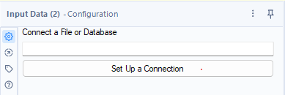

Click on files > Select File

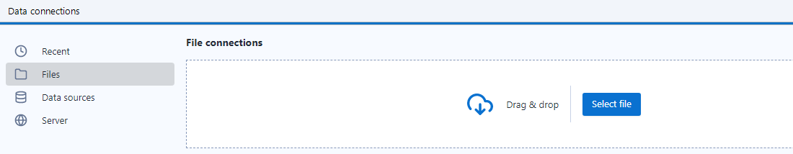

And locate your final_real_estate.csv file on your laptop. This file you should have generated as an output file from your lab6 Alteryx workflow.

Once successfully located, you should see a preview of your data in the configuration window

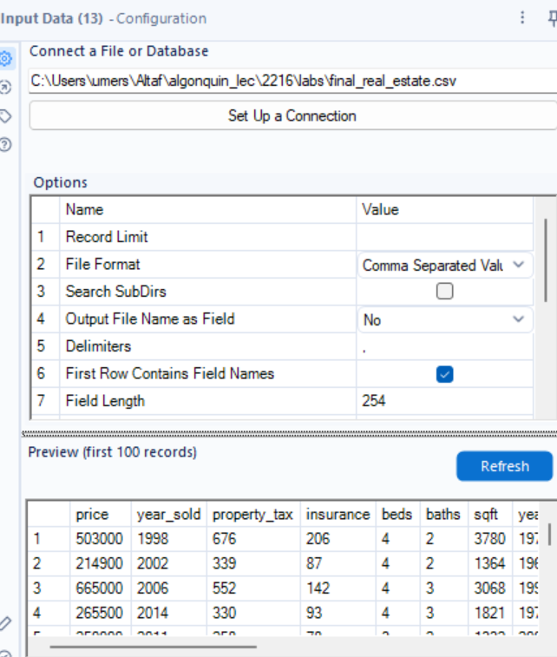

Let’s change the data types of the columns as per data types mentioned in the data dictionary

Select Tool
Read more about this tool here:
https://help.alteryx.com/20232/en/designer/tools/preparation/select-tool.html
Connect a Select tool to the Input tool. The select tool should be in your favourites (or in the Preparation Tab).
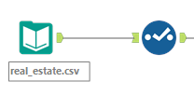

When you click on Select tool, you will see on the left
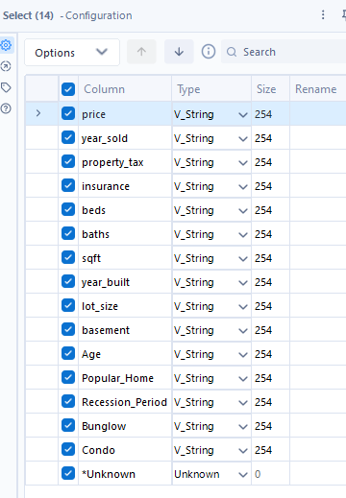

Change the data types to the following and uncheck the *Unknown column. You can also use select tool to filter columns and rename columns.
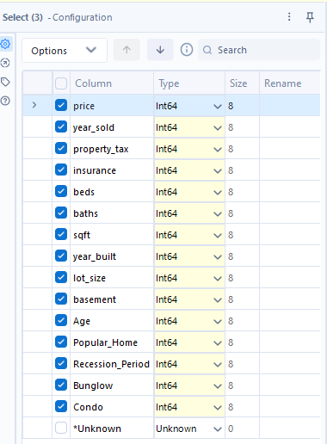

Next, click on the select tool and in the configuration tool (on the left) click on the annotation option.

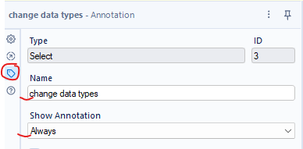

Edit the Name to “change data types” and change Show Annotation to “Always”
This will change the appearance of the Input tool to as shown below

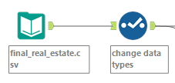

This is always a best practice. This helps you and others looking at your workflow to understand what each tool is being used for.

Now let’s analyse the data to find associations between the independent variables (input features) with the target variable, price.

Association Analysis tool

Read more about this tool here:
https://help.alteryx.com/20232/en/designer/tools/data-investigation/association-analysis-tool.html

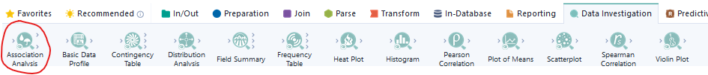

- Add this tool to your favourites by clicking on the star on top of the tool.

Connect the association analysis tool to the output of the select tool.
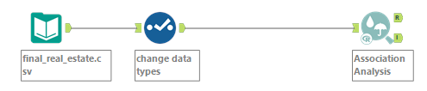

Click on the association analysis tool and in the Configuration window, switch to Annotation option, and configure the association tool as below
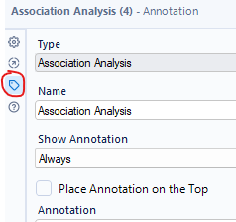
Annotation option
Configuration option

Switch back to Configuration option, check the option “Target a field for more detailed analysis”
This will give you a drop down option to select the target variable. Select the column “price”
In the next window, Select all fields other than “price” and “condo” i.e. Uncheck “price” and “condo” column from the list.
Select the Pearson product-moment correlation option in the next window.

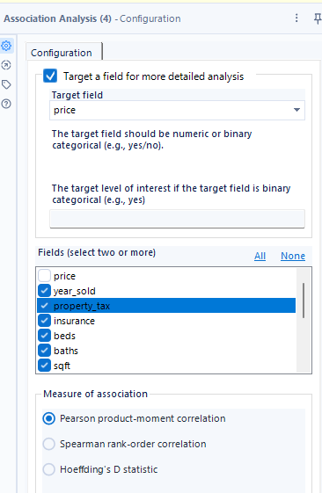

Next, connect 2 Browse tools to the two output anchors (I, R) of the association analysis tool.
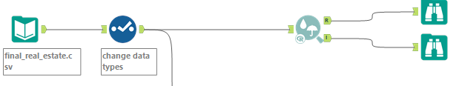

- The browse tool should be in your favourites.
Now click on Run
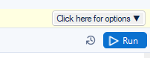
Click on every browse tool one by one and observe the output in the configuration Window. The Browse tool from R anchor of association tool shows you a correlation matrix like below
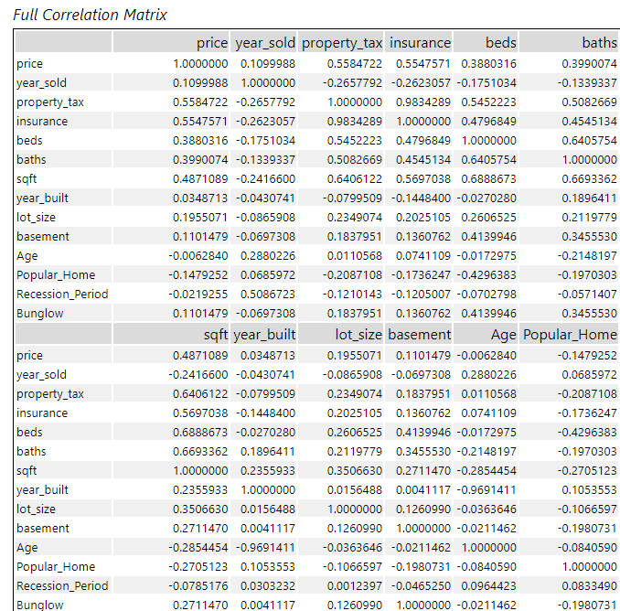

The Browse tool from I anchor of association tool shows the interactive heatmap of the correlation matrix.
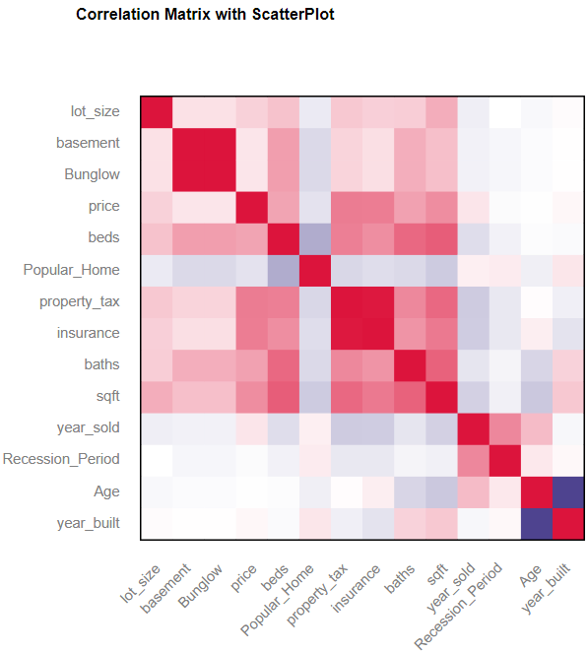
As discussed in the class, lets split the data in training and testing datasets. The training data will be used to train the model, and the testing data will be used to evaluate the performance of the model on an unseen data.

Create Samples Tool
Read more about this tool here:
https://help.alteryx.com/20232/en/designer/tools/preparation/create-samples-tool.html
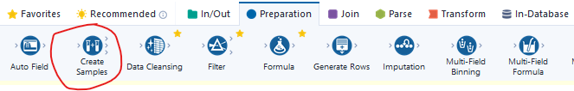

Connect the Create Samples tool to the output of the Select Tool
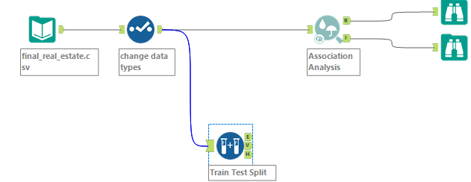

Modify the following values in the configuration option and the Annotation option as done previously.
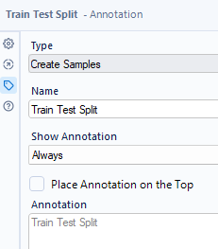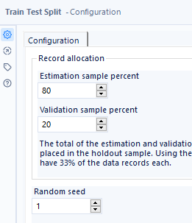
Now, lets train a Linear Regression Model
Linear Regression Tool
Read more about this tool here:
https://help.alteryx.com/20232/en/designer/tools/predictive/linear-regression-tool.html

Connect the Linear Regressio tool to the E output anchor of the Create Samples Tool and attach a Browse tool to the I output anchor of the Linear Regression tool
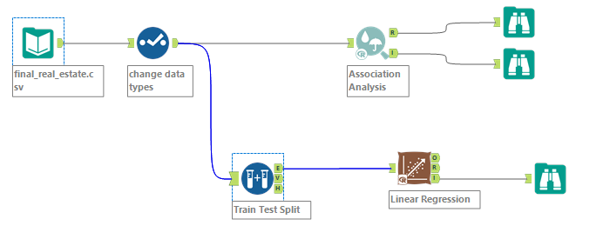
Configure the Linear Regression tool with the following values as done before
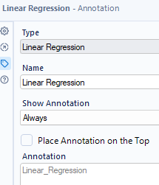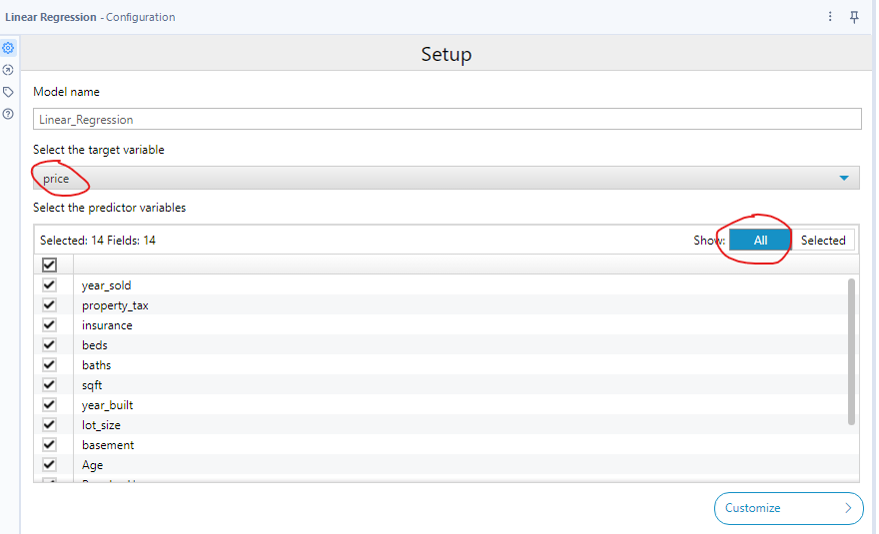
Now click on Run
Now click the browse tool. This should show you the model performance.
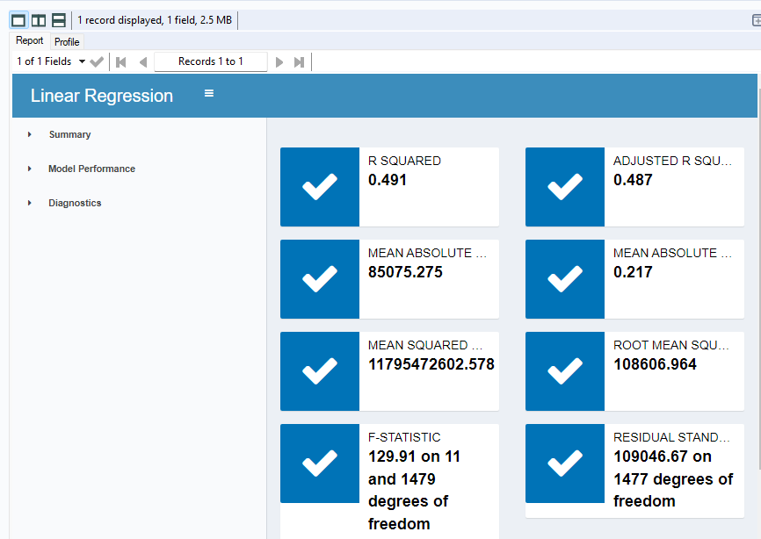

We have successfully trained a Linear Regression Model.
Now let’s test the model performance on the test data.

Score Tool
Read more about this tool here:
https://help.alteryx.com/current/en/designer/tools/predictive/score-tool.html

Connect the O output anchor of the Linear Regression tool to the D input of the Score tool, and the H output of the V output anchor of the linear regression to the M input of the Score tool.

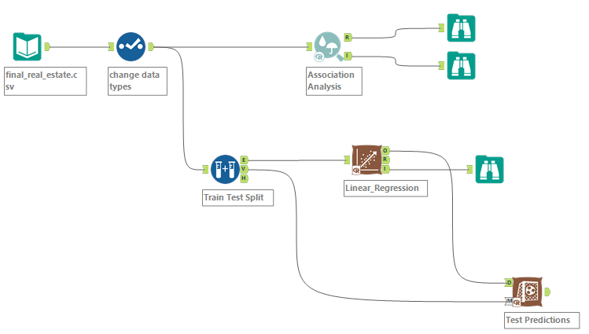

Do the following configuration settings
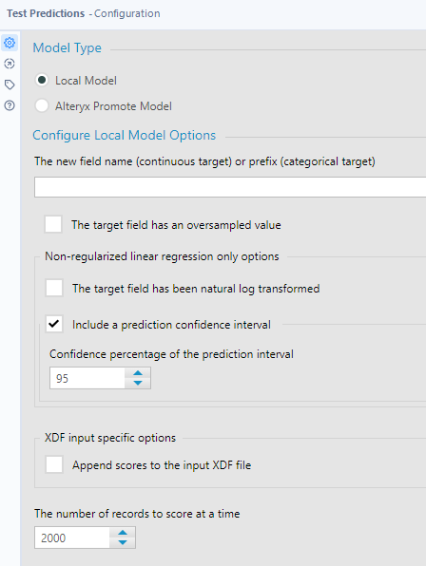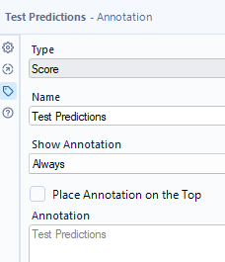

Now click on Run

Formula Tool
Read more about this tool here:
https://help.alteryx.com/current/en/designer/tools/preparation/formula-tool.html
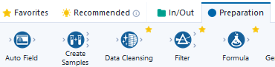

Add a Formula tool to the output of the Score tool and add a Browse tool to the output of the Formula tool.
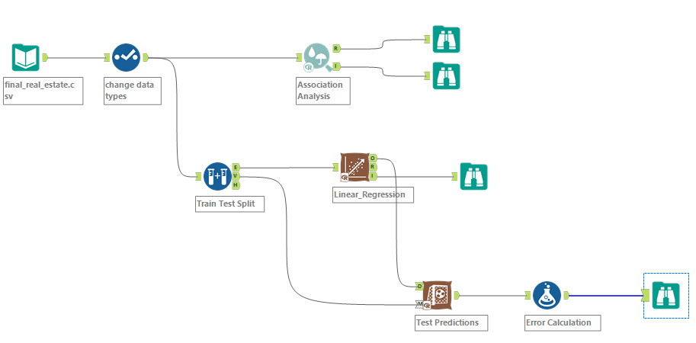

Do the following modifications in the Formula tool

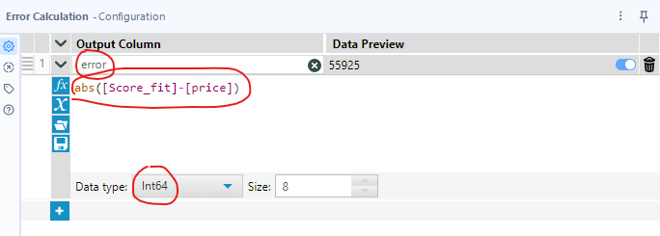
abs([Score_fit]-[price])
And
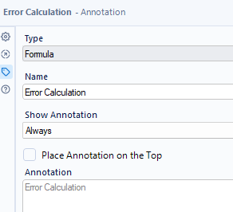

Now click on Run
Finally, click on the final browse tool and your results window will show the actuals, predictions and the error on the test set.
